**Logic Gates Using Verilog HDL**

This Verilog code demonstrates the implementation of basic **logic gates**—AND, OR, and NOT. Logic gates are the fundamental building blocks of digital circuits, performing basic logical functions essential for digital computation.

**Module Description:**

The module is named logic_gates and has:

* **Inputs:**
  + a_in (Input A)
  + b_in (Input B)
* **Outputs:**
  + y_and_out (Output of AND gate)
  + y_or_out (Output of OR gate)
  + y_not_out (Output of NOT gate applied to a_in)
* **Code Explanation:**

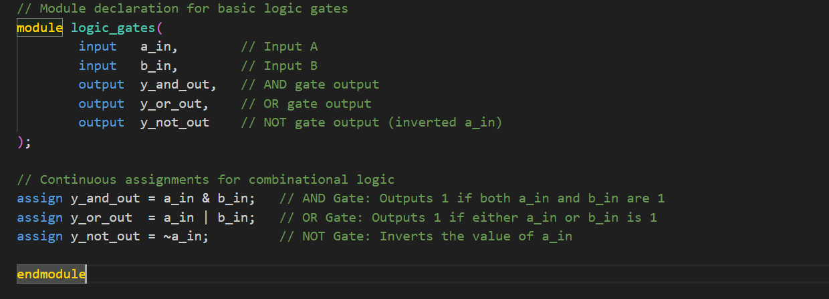

* **assign Statement:**  
  Used for continuous assignments in combinational logic.
* **Gate Operations:**
  + & → **AND Gate:** Outputs 1 only if both a_in and b_in are 1.
  + | → **OR Gate:** Outputs 1 if at least one input is 1.
  + ~ → **NOT Gate:** Inverts the value of a_in.

**Truth Table:**

|  |  |  |  |  |
| --- | --- | --- | --- | --- |
| **a_in** | **b_in** | **y_and_out (AND)** | **y_or_out (OR)** | **y_not_out (NOT a_in)** |
| 0 | 0 | 0 | 0 | 1 |
| 0 | 1 | 0 | 1 | 1 |
| 1 | 0 | 0 | 1 | 0 |
| 1 | 1 | 1 | 1 | 0 |

**Testbench for Logic Gates**

To verify the functionality of the logic_gates module, we use a **testbench**. A testbench is a simulation environment used to apply test vectors to the design and observe the outputs.

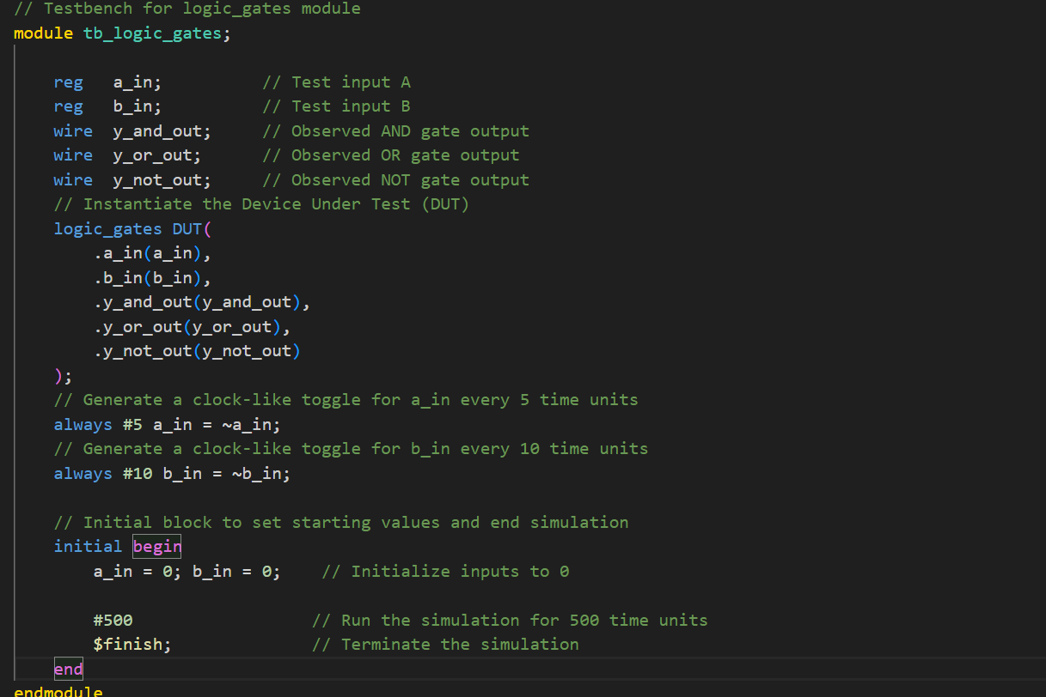

* **Testbench Components:**
  + **Registers (reg):** Declared for a_in and b_in to apply test values.
  + **Wires (wire):** Connected to outputs to observe the results.
  + **Instantiation:** The logic_gates module is instantiated as DUT (Device Under Test).
* **Stimulus Generation:**
  + **always Blocks:** Toggle a_in every 5 time units and b_in every 10 time units to generate test patterns.
  + **initial Block:** Sets initial conditions and ends the simulation after 500 time units.
* **Simulation Control:**
  + **$finish** is used to stop the simulation after the desired time.

**Applications:**

* **AND Gate:** Digital circuits for condition checking.
* **OR Gate:** Alarm systems, control circuits.
* **NOT Gate:** Inverters, signal conditioning.